Comparison of Numbers

In comparison of numbers we will learn to compare 4-digit numbers. The same rules are applied to compare numbers having more than 4 digits.
Compare:
(a) 5869 and 4369
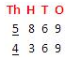
5 > 4
So, 5869 > 4369
(b) 74186 and 74586
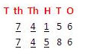
7 = 7
4 = 4
1 < 5
So, 74586 > 74186

